Packet Tracer - Basic Switch and End Device Configuration

Tursynbay Mansur CS - 2428

Addressing Table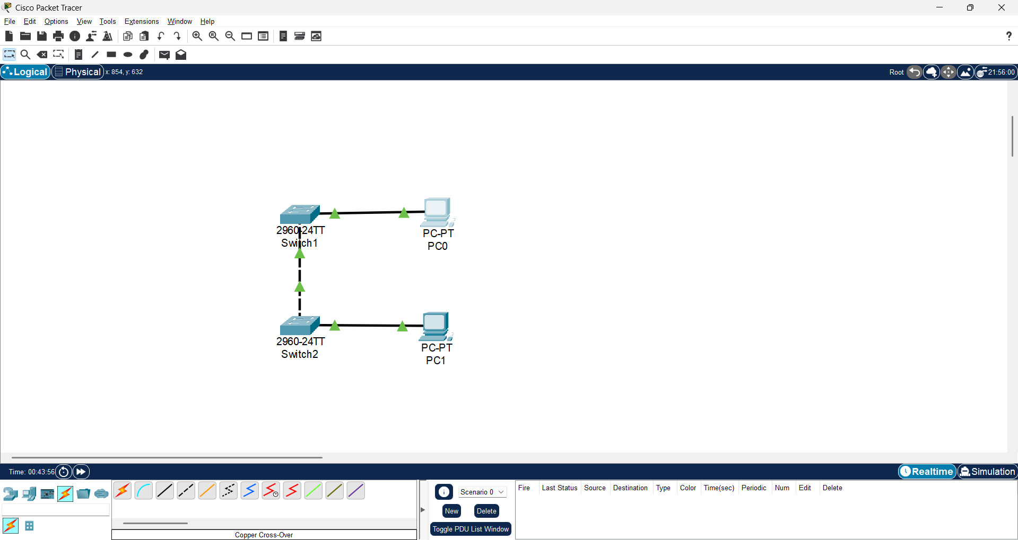
Device | Interface | IP Address | Subnet Mask
Switch1 | VLAN 1 | 192.168.1.1 | 255.255.255.0
Switch2 | VLAN 1 | 192.168.1.2 | 255.255.255.0
PC0 | NIC | 192.168.1.3 | 255.255.255.0
PC1 | NIC | 192.168.1.4 | 255.255.255.0

Objectives
- Configure hostnames and IP addresses on two Cisco Internetwork Operating System (IOS) switches using the command-line interface (CLI).
- Use Cisco IOS commands to specify or limit access to the device configurations.
- Use IOS commands to save the running configuration.
- Configure two host devices with IP addresses.
- Verify connectivity between the two PC end devices.

Scenario
As a recently hired LAN technician, your network manager has asked you to demonstrate your ability to configure a small LAN. Your tasks include configuring initial settings on two switches using the Cisco IOS and configuring IP address parameters on host devices to provide end-to-end connectivity. You are to use two switches and two hosts/PCs on a cabled and powered network.

Instructions
Configure the devices to fulfill the requirements below.

Requirements
- Use a console connection to access each switch. 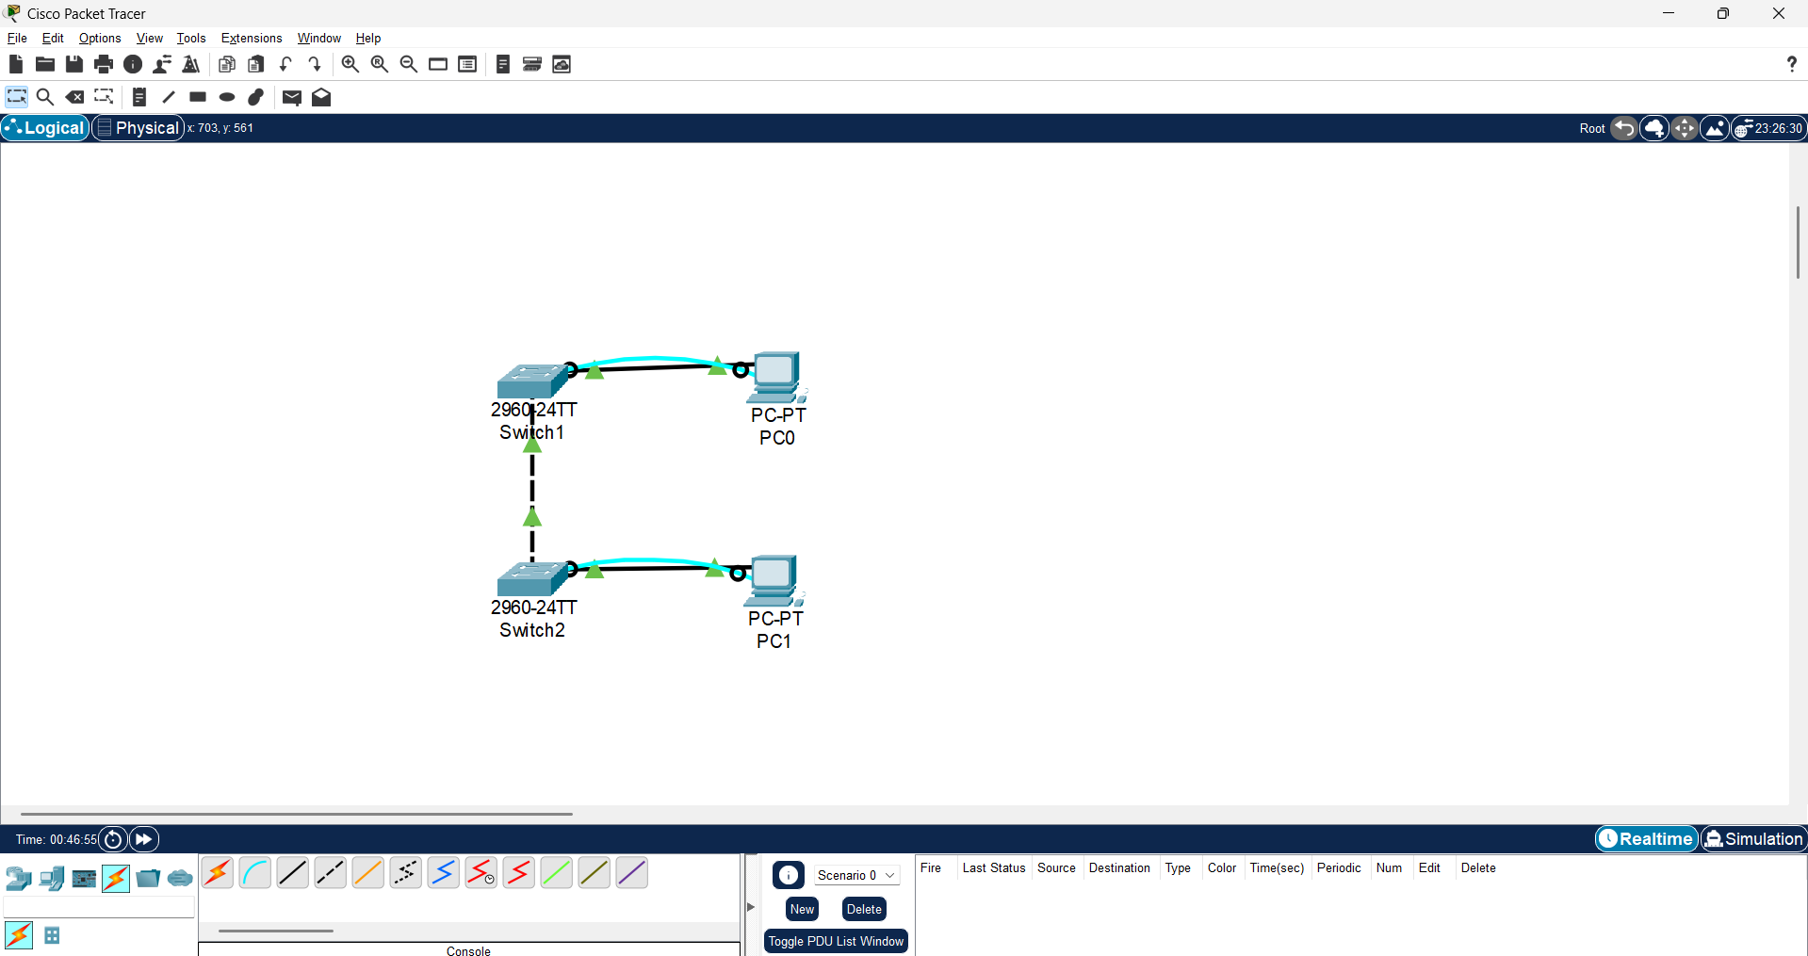
- Name Switch1 and Switch2 switches. 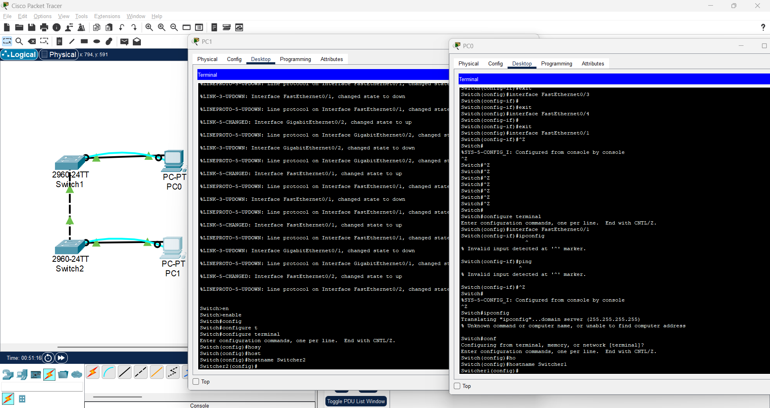
- Use the Mansur password for all lines. 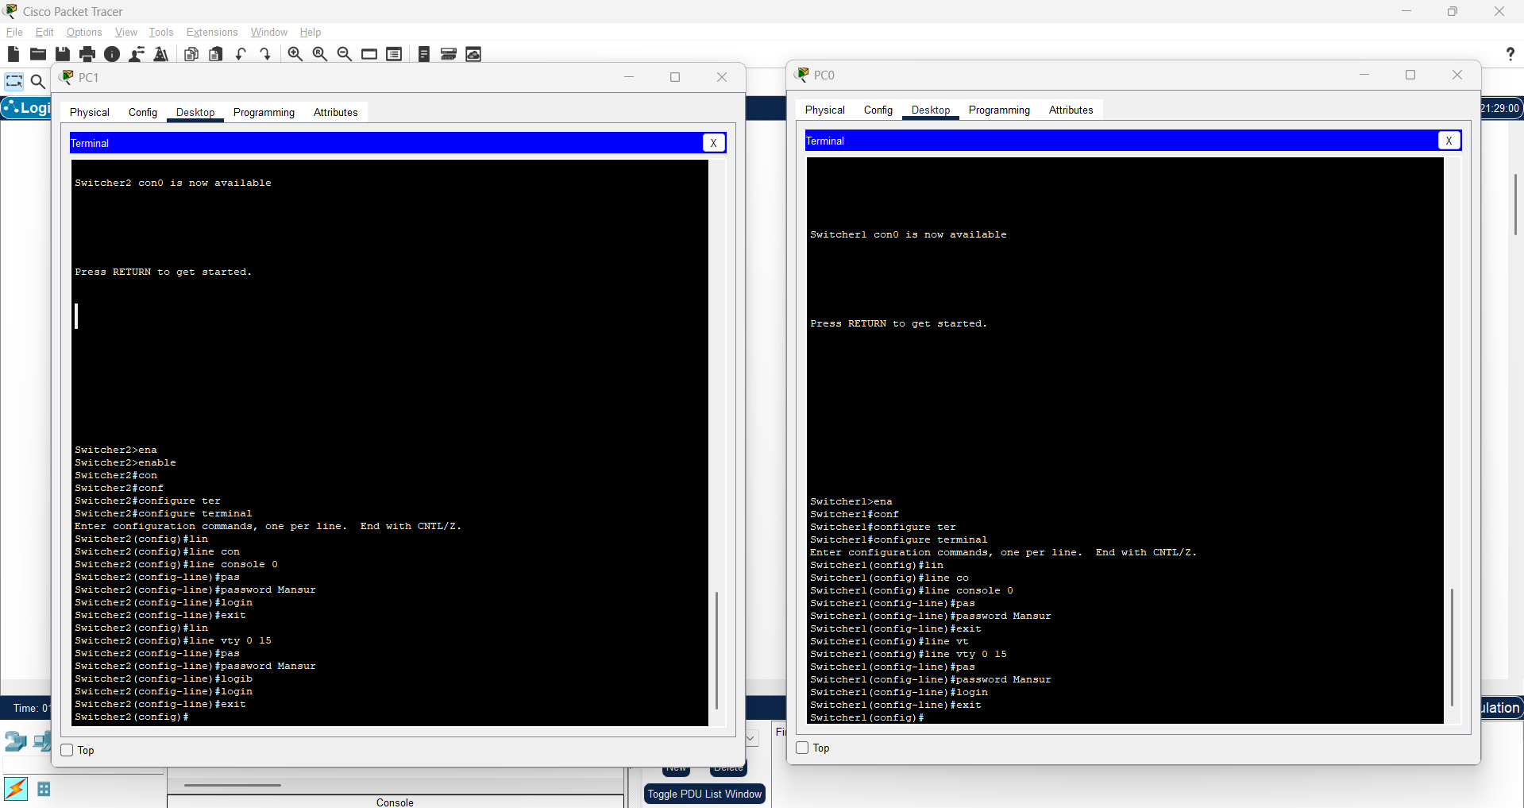
- Use the Tursynbay secret password. 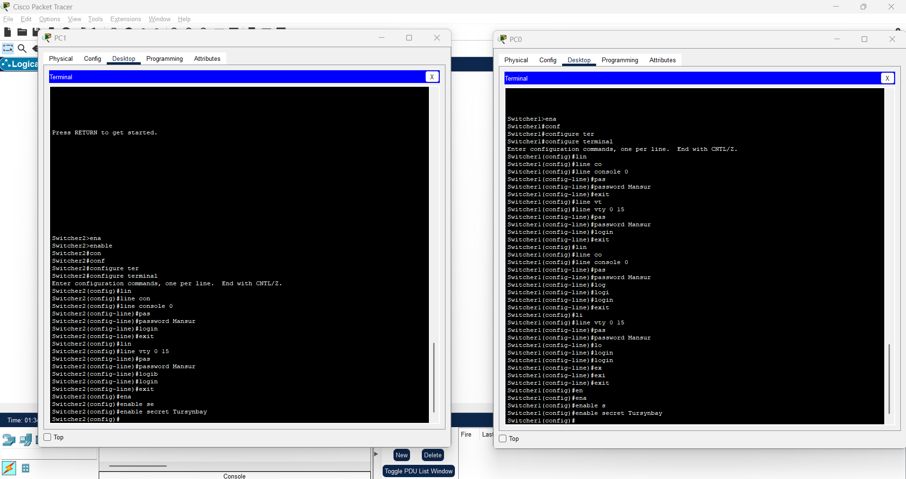
- Encrypt all clear text passwords. 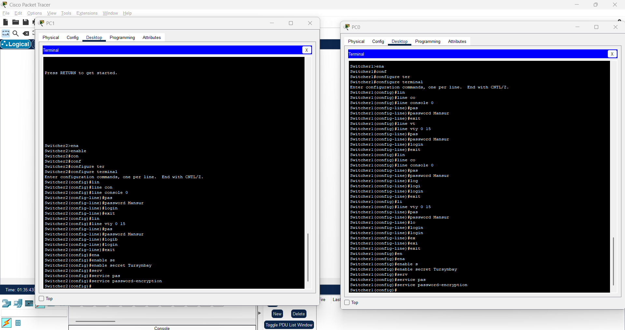
- Configure an appropriate message-of-the-day (MOTD) banner. 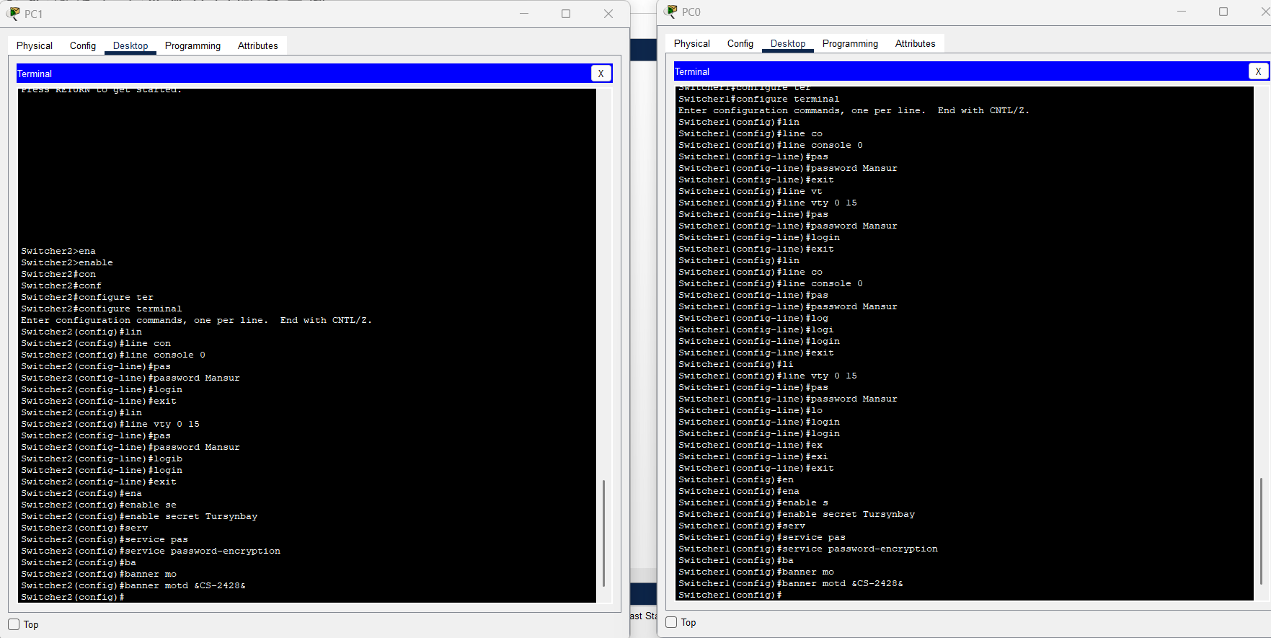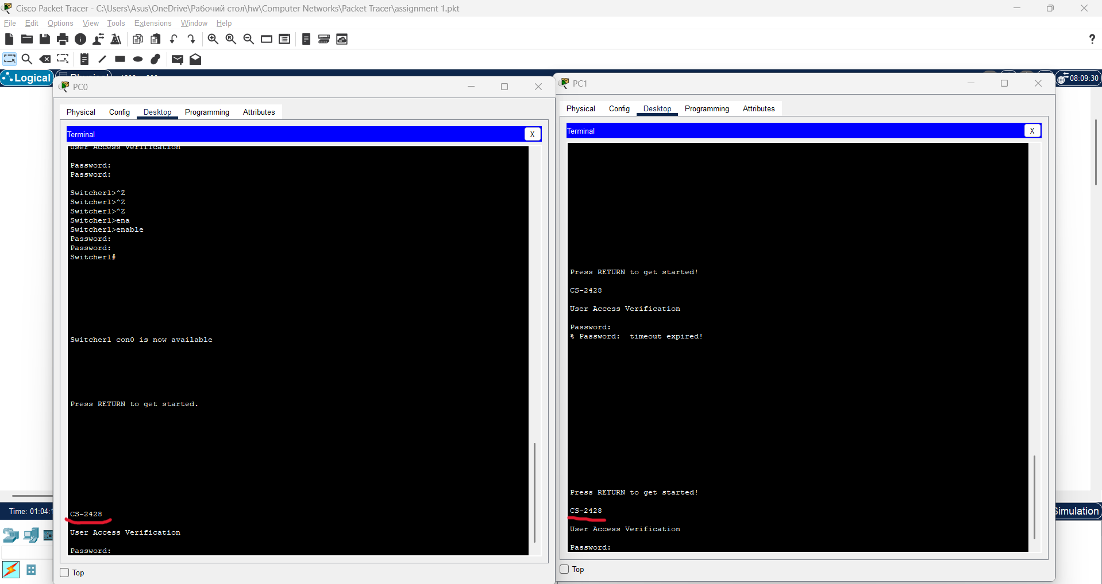

- Configure addressing for all devices according to the Addressing Table. 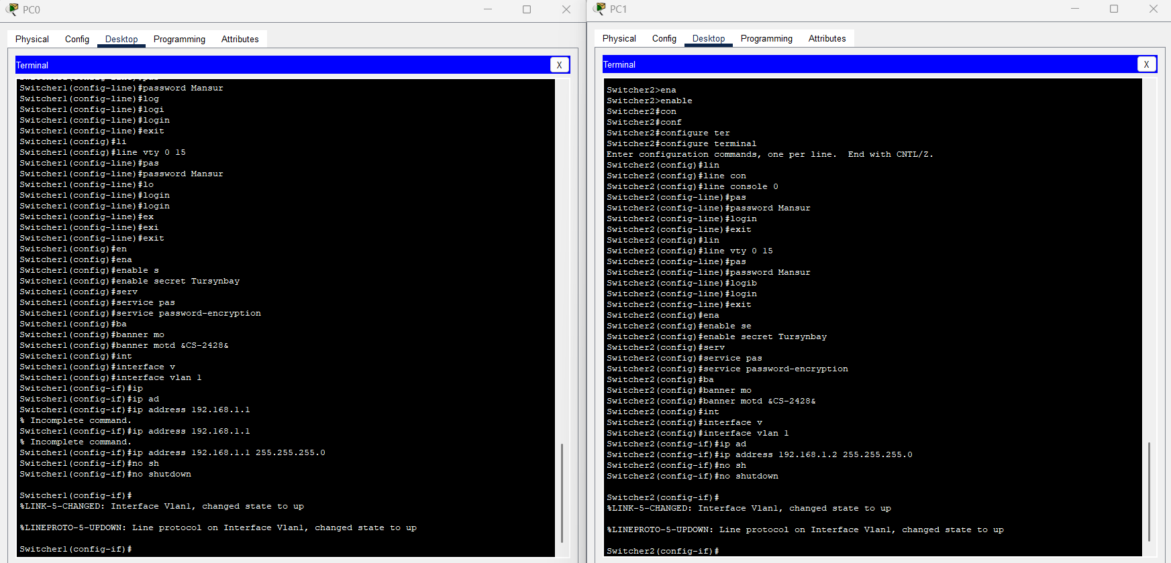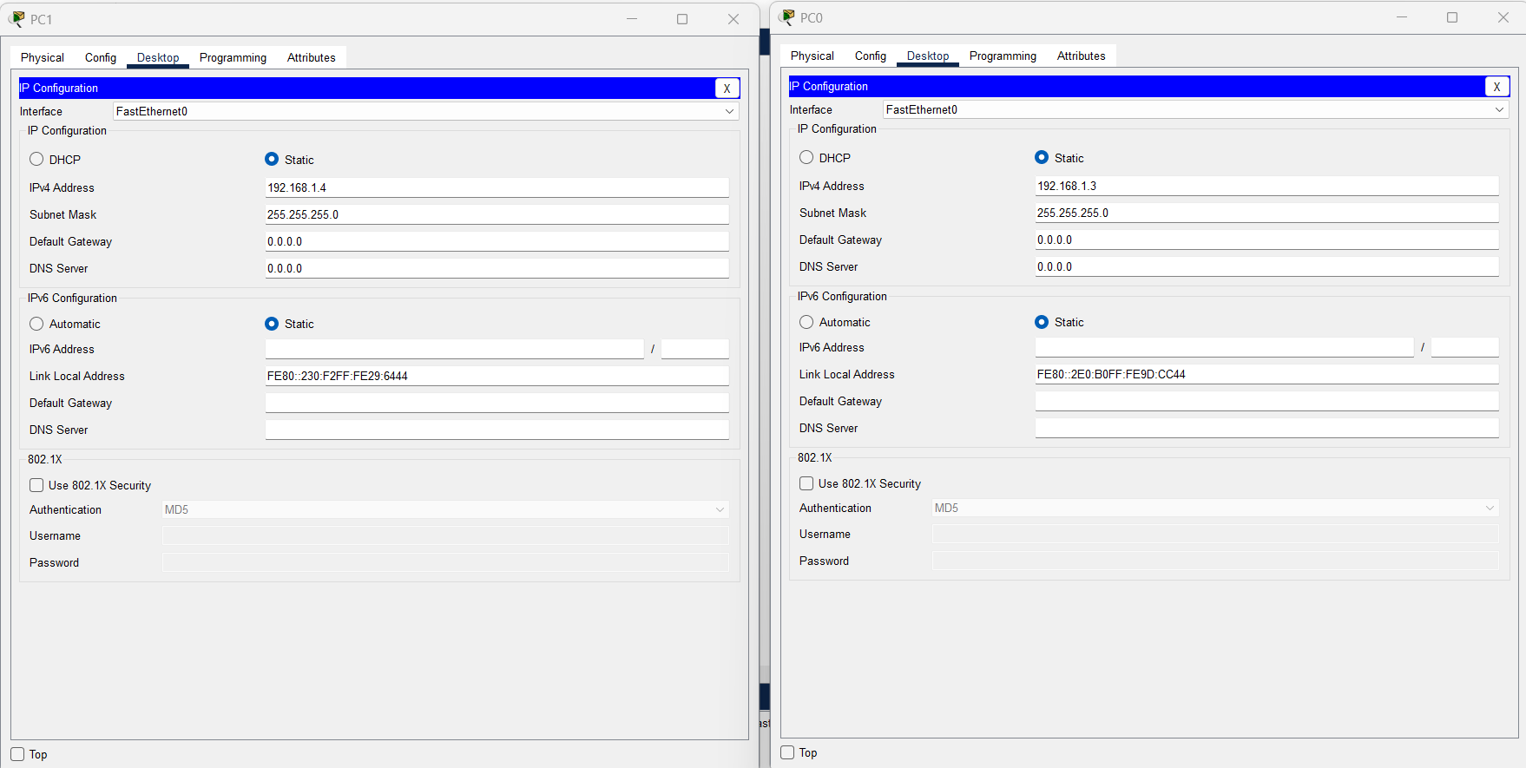
- Save your configurations. 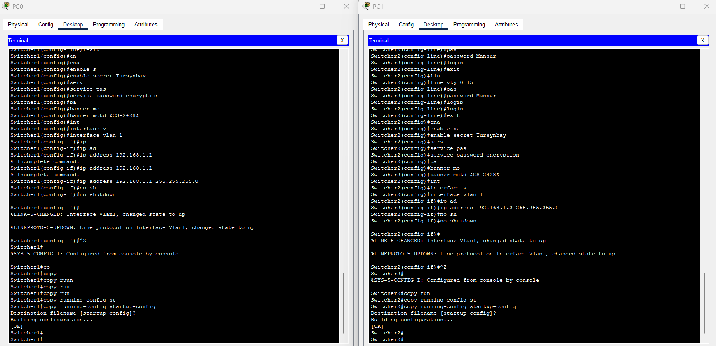
- Verify connectivity between all devices. 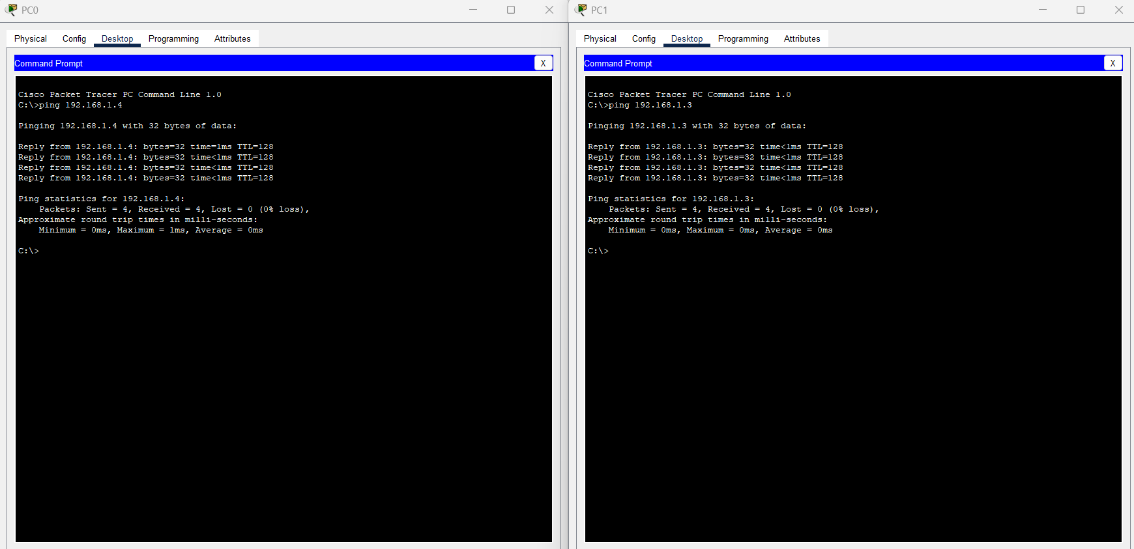
Note: Click Check Results to see your progress. Click Reset Activity to generate a new set of requirements. If you click on this before you complete the activity, all configurations will be lost.
End of Document

